Library management system

Test Case: Scanning Books

TC02

**Version History**

|  |  |  |  |
| --- | --- | --- | --- |
| **Version** | **Date** | **Description** | **Author** |
| 1.0 | 1/10/2016 | Initial version | KAMAL RAJ KANDEL |

|  |  |
| --- | --- |
| **Test Case ID** | **TC01** |
| **Test Case Name** | Scanning books |
| **Description** | This test case tests the process that the user must scan the barcode of the books in order to borrow. It tests the following possible scenarios:   * User enter the correct barcode(TS01_01) * User enter the wrong barcode(TS02_02). * User enter the negative integer as barcode or simply just leave empty(TS03_03). * User scan multiple books unless it reaches maximum(TS04_04). |
| **Pre-Conditions** | User should not have fine exceeding $10, shouldn’t have overdue loans and should not have taken more than 5 books. |
| **Post-Conditions** | System displays the details along with the due date to return the book. |

|  |  |
| --- | --- |
| **Data Required** | |
| Member ID | Integer type starting from 1 to 15 |

# Test script

**Version History**

|  |  |  |  |
| --- | --- | --- | --- |
| **Version** | **Date** | **Description** | **Author** |
| 1.0 | 1/10/2016 | Initial version | KAMAL RAJ KANDEL |

## The following test script were evaluated to test the scanning the book test case.

## 

|  |  |
| --- | --- |
| **Test ID:** | **TS01_01** |
| **Test Name:** | **User scans the correct barcode of the book.** |
| **Use Case Tested:** | Borrow books |
| **Test Description:** | Test how the system responds when the user scans the correct barcode of the book. |
| **Pre-conditions:** | The user must have the library member card, should not have fine exceeding $10, should not have overdue loans and shouldn’t have taken more than 5 books. |
| **Post-conditions:** | System display the book details. |
| **Notes:** | The barcode of the book should be properly entered and scanned. |
| **Result**  **(Pass/ Fail/ Warning/ Incomplete)** |  |

|  |  |  |  |  |
| --- | --- | --- | --- | --- |
| **Step Number** | **Test Step** | **Expected Test Results** | **Pass** | **Fail** |
| **1.** | User click on borrow books. | System display the card reader forum. |  |  |
| **2.** | User swipes the card | System display the user loan history and activate the barcode scanner. |  |  |
| **3.** | User scan the barcode of the book. | System display the book details along with the due date to retun. |  |  |

|  |  |  |  |  |  |  |
| --- | --- | --- | --- | --- | --- | --- |
| **Test Data Table** | | | | | |  |
| Member id | 1 | 2 | 3 | 4 | 5 | 6 |
| Correct Barcode of the book. | 10 | 11 | 12 | 13 | 14 | 15 |

# 

# Result On The Screen

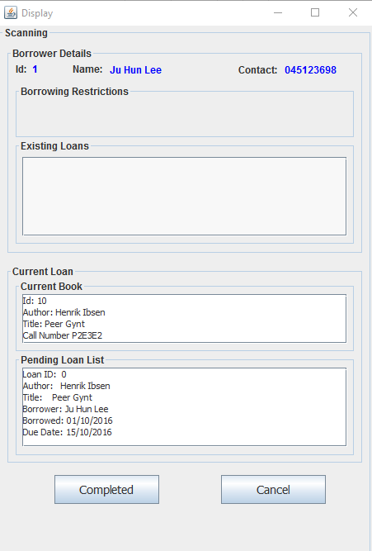

|  |  |
| --- | --- |
| **Test ID:** | **TS02_02** |
| **Test Name:** | **User enter the wrong barcode.** |
| **Use Case Tested:** | Borrow books. |
| **Test Description:** | Test how the system responds when the user enters the wrong barcode. |
| **Pre-conditions:** | The user must have the library member card, should not have fine exceeding $10, should not have overdue loans and shouldn’t have taken more than 5 books. |
| **Post-conditions:** | System display not found message. |
| **Notes:** | The book barcode should be correct. |
| **Result**  **(Pass/ Fail/ Warning/ Incomplete)** |  |

|  |  |  |  |  |
| --- | --- | --- | --- | --- |
| **Step Number** | **Test Step** | **Expected Test Results** | **Pass** | **Fail** |
| **1.** | User click on borrow books. | System display the card reader forum. |  |  |
| **2.** | User swipes the card | System display the user loan history and activate the barcode scanner. |  |  |
| **3.** | User enter the wrong barcode. | System display the book not found message. |  |  |

|  |  |  |  |  |  |  |
| --- | --- | --- | --- | --- | --- | --- |
| **Test Data Table** | | | | | |  |
| Member id | 1 | 2 | 3 | 4 | 5 | 6 |
| Wrong barcode | 16 | 17 | 18 | 19 | 20 | 21 |

# Result on the Screen

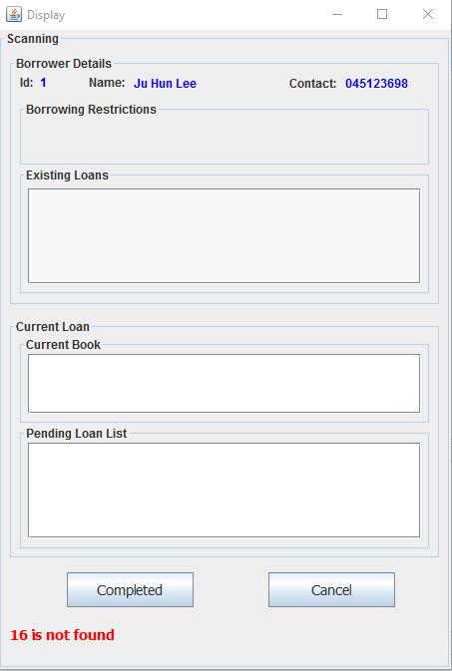

|  |  |
| --- | --- |
| **Test ID:** | **TS03_03** |
| **Test Name:** | User enter the negative integer as barcode or simply just leave empty |
| **Use Case Tested:** | Borrow books. |
| **Test Description:** | Test how the system responds when the user enters the wrong barcode. |
| **Pre-conditions:** | The user must have the library member card, should not have fine exceeding $10, should not have overdue loans and shouldn’t have taken more than 5 books. |
| **Post-conditions:** | System display book barcode must be positive integer. |
| **Notes:** | The book barcode should be positive integer. |
| **Result**  **(Pass/ Fail/ Warning/ Incomplete)** |  |

|  |  |  |  |  |
| --- | --- | --- | --- | --- |
| **Step Number** | **Test Step** | **Expected Test Results** | **Pass** | **Fail** |
| **1.** | User click on borrow books. | System display the card reader forum. |  |  |
| **2.** | User swipes the card | System display the user loan history and activate the barcode scanner. |  |  |
| **3.** | User enter the negative integer or leave empty. | System display the book barcode must be positive integer. |  |  |

|  |  |  |  |  |  |  |
| --- | --- | --- | --- | --- | --- | --- |
| **Test Data Table** | | | | | |  |
| Member id | 1 | 2 | 3 | 4 | 5 | 6 |
| Negative barcode | -10 | -11 | -12 | -13 | -14 | -15 |

# Result on the Screen

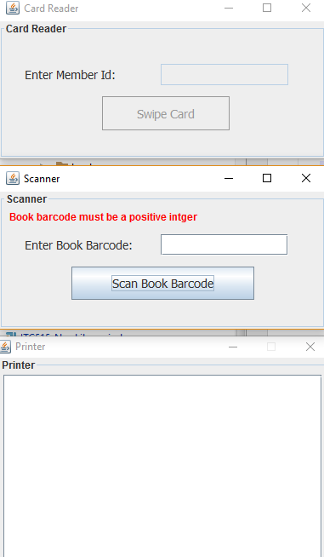

## 

## 

|  |  |
| --- | --- |
| **Test ID:** | **TS04_04** |
| **Test Name:** | User scan the multiple book up to 5 unless restricted. |
| **Use Case Tested:** | Borrow books |
| **Test Description:** | Test how the system responds when the user scans the multiple books may be 5 at a time. |
| **Pre-conditions:** | The user must have the library member card, should not have fine exceeding $10, should not have overdue loans. |
| **Post-conditions:** | User can borrow multiple books. |
| **Notes:** | The barcode of the book should be properly entered and scanned. |
| **Result**  **(Pass/ Fail/ Warning/ Incomplete)** |  |

|  |  |  |  |  |
| --- | --- | --- | --- | --- |
| **Step Number** | **Test Step** | **Expected Test Results** | **Pass** | **Fail** |
| **1.** | User click on borrow books. | System display the card reader forum. |  |  |
| **2.** | User swipes the card | System display the user loan history and activate the barcode scanner. |  |  |
| **3.** | User scan the barcode of the book. | System display the book details along with the due date to return. |  |  |
| **4.** | User repeat the process of scanning books till the user is restricted. | Once the user is restricted then the system redirects the user to the confirmation page. |  |  |

|  |  |
| --- | --- |
| **Test Data Table** | |
| Member id | 6 |
| Correct Barcode of the book. | 10 |
| ‘’ | 11 |
| ‘’ | 12 |

# On the above table the member 6 scans the 3 books at a time and the system automatically direct him to the loan confirmation page. The reason the system redirects is that this member had borrowed 2 books in the past.

# 

# Result On the Screen

